WELEARN
A Skills-Based Digital Learning Platform Bridging Education and Employability
Final

Table of Contents
Slide 1 — Title
Slide 2 — Agenda
Slide 3 — Problem Statement
Slide 4 — Platform Overview
Slide 5 — Course Catalogue
Slide 6 — System Architecture
Slide 7 — SDLC
Slide 8 — Project Plan
Slide 9 — UML Diagrams
Slide 10 — Prototype & UI/UX
Slide 11 — SDG 4 Alignment
Slide 12 — License & GitHub
Slide 13 — Conclusion

Executive Summary

WELEARN is a digital skills-based learning platform designed to bridge the gap between formal education and real-world employability in Sierra Leone and across sub-Saharan Africa. While aligned with the United Nations Sustainable Development Goal 4 (SDG 4) — Quality Education — WELEARN specifically addresses the employability dimension of education: equipping youth and young professionals with practical, job-ready skills in technology, design, business, and creative disciplines that formal schooling alone does not adequately provide.
The platform offers structured, self-paced courses across nine core domains: Programming, Design, Arts and Crafts, Accounting, Economics, Marketing, Database, Digital Imaging, and Data Analysis. Each domain is broken into focused subtopics — for example, Programming includes HTML & CSS, JavaScript, and Programming Logic, while Arts and Crafts includes Perspective Drawing, 2D Drawing, and 3D Drawing. This structure allows learners to build a practical, modular skillset aligned with current labour market demand.
WELEARN addresses a critical socioeconomic challenge: high youth unemployment driven not by a lack of ambition, but by a structural skills gap between what is taught in classrooms and what employers and the freelance economy require. By offering free or low-cost, accessible, skills-first education, WELEARN positions itself as a Digital Public Good that directly contributes to reducing youth unemployment while advancing SDG 4.
This document presents the complete software design for WELEARN, covering the Software Development Life Cycle (SDLC), system architecture, UML diagrams, project plan with Gantt chart and network diagram, prototype design, licensing, and supporting technical documentation.

1 Mission
To provide accessible, affordable, and industry-relevant digital skills training that prepares young people for employment and entrepreneurship opportunities.

Vision
To become Sierra Leone's leading digital learning platform for developing job-ready skills and fostering lifelong learning.

2. Problem Statement & SDG Alignment

Problem Statement
Sierra Leone and many other developing nations face a persistent and growing skills-employment mismatch:
- Youth unemployment in Sierra Leone remains above 60% among individuals aged 15–35, despite rising secondary and tertiary enrolment.
- Formal curricula often emphasise theory over practical, market-relevant skills such as programming, digital design, and data literacy.
- Vocational and technical training centres are scarce outside Freetown, and where they exist, they are often under-resourced or outdated.
- Access to international online learning platforms (Coursera, Udemy) is limited by cost (in foreign currency), data requirements, and lack of localisation.
- Many graduates leave school technically "educated" but unable to perform job-ready tasks expected by employers or the freelance/digital economy.
This mismatch traps a large segment of Sierra Leone's youth population in a cycle of underemployment, despite a global digital economy that increasingly rewards practical, demonstrable skills over formal credentials alone. WELEARN directly responds to this by connecting education with employability — equipping learners with practical skills that match current labour market demands, and empowering young people to pursue both employment and entrepreneurship opportunities that contribute to national development.

SDG 4 — Quality Education
WELEARN is aligned with United Nations Sustainable Development Goal 4: Ensure inclusive and equitable quality education and promote lifelong learning opportunities for all. WELEARN responds to the following SDG 4 targets:
 | Description | WELEARN Response
 | Equal access to affordable technical, vocational and tertiary education | Free/low-cost skills courses accessible to all, regardless of formal academic background
 | Increase the number of youth with relevant skills for employment | Job-market-aligned curriculum: Programming, Design, Data Analysis, Marketing, etc.
 | Eliminate gender and access disparities in education | Free social sign-up reduces barriers; mobile-friendly design for broad access
 | Ensure learners acquire knowledge needed to promote sustainable development | Includes practical, applicable disciplines tied directly to local economic opportunity

3. Software Development Life Cycle (SDLC)

Selected SDLC Model: Agile (Scrum Framework)
WELEARN will be developed using the Agile SDLC model, specifically the Scrum framework. This model was selected because:
- The course catalogue and curriculum structure are likely to evolve as new skill domains and learner feedback emerge — Agile accommodates this continuous change well.
- Short, fixed-length sprints (2 weeks) allow working features to be delivered, tested, and refined frequently.
- Multiple stakeholder groups — learners, subject-matter instructors, partner organisations, and university supervisors — require regular visibility into progress.
- Iterative delivery reduces the risk of building course features or platform tools that ultimately do not match learner needs.

SDLC Phases for WELEARN

Phase 1: Planning (Weeks 1–2)
This phase establishes the project's scope, objectives, and feasibility. Activities include stakeholder identification (university supervisors, prospective instructors, target learner groups), resource allocation, risk analysis, and creation of the initial Product Backlog. A Project Charter is produced defining the platform's vision, target skill domains, and success metrics. The team is structured as: Scrum Master, Product Owner, 3 developers, 1 UI/UX designer, and 1 content/curriculum coordinator.

Phase 2: Requirements Analysis (Weeks 2–3)
Functional and non-functional requirements are gathered through learner surveys and informal interviews with target users (students, recent graduates, informal-sector workers seeking new skills). Use case analysis identifies the primary actors — Learner, Instructor, and Administrator — and their respective interactions. User stories are written and prioritised. Non-functional requirements include mobile-first responsive design, support for low-bandwidth environments, and an accessible sign-up flow (including social authentication) to minimise onboarding friction.

Phase 3: System Design (Weeks 3–5)
The system architecture, database schema, API design, and UI/UX wireframes are produced. UML diagrams (Use Case, Class, Sequence, and Activity diagrams) model system behaviour and structure. The technology stack is finalised: React.js (web frontend), Node.js + Express (backend API), PostgreSQL (database), and AWS S3 (course content storage). This phase produces the System Design Document and the initial Figma prototype.

Phase 4: Implementation — Sprints (Weeks 5–18)
Development proceeds across 7 two-week Sprints. Each Sprint begins with Sprint Planning, includes daily stand-ups, and concludes with a Sprint Review and Retrospective. Key deliverables: user authentication & social sign-up (Sprint 1), course catalogue & category browsing (Sprint 2), course/lesson content player (Sprint 3), progress tracking & certificates (Sprint 4), instructor content tools (Sprint 5), admin panel (Sprint 6), and final integration and polish (Sprint 7).

Phase 5: Testing (Weeks 12–19, Ongoing)
Testing is embedded throughout development (test-driven development) with a dedicated testing phase overlapping the final sprints. Test types include Unit Testing (Jest), Integration Testing (Supertest for API endpoints), User Acceptance Testing (UAT) with a sample group of learners, and performance testing for low-bandwidth conditions. GitHub Issues is used for bug tracking.

Phase 6: Deployment (Weeks 19–20)
WELEARN is deployed using a CI/CD pipeline (GitHub Actions) to AWS infrastructure (EC2, RDS, S3, CloudFront). A soft launch is conducted with a small cohort of learners before public release. Server monitoring is configured via AWS CloudWatch.

Phase 7: Maintenance & Iteration (Ongoing)
Post-launch, the team monitors usage analytics and learner feedback to guide future course additions and platform improvements. New skill categories are added quarterly based on labour market demand signals. Security patches are applied promptly, and a continuing Agile cycle of new sprints addresses user-requested features.
Phase | Duration | Timeline | Key Output
Planning | 2 weeks | Week 1–2 | Project Charter, Risk Register
Requirements | 2 weeks | Week 2–3 | Product Backlog, User Stories
Design | 3 weeks | Week 3–5 | System Design Doc, UML Diagrams, Figma Prototype
Implementation | 14 weeks | Week 5–18 | Working Software (7 Sprints)
Testing | 8 weeks | Week 12–19 | Test Reports, Bug Fixes
Deployment | 2 weeks | Week 19–20 | Live Application, Public Launch
Maintenance | Ongoing | Week 21+ | Updates, New Courses, Patches

4. System Architecture Design

Architecture Overview
WELEARN follows a Three-Tier Client-Server Architecture: a Presentation Tier (responsive web application), an Application Tier (Node.js REST API server), and a Data Tier (PostgreSQL relational database and AWS S3 content storage).

Architecture Diagram Description
- CLIENT LAYER: Learners and instructors access WELEARN via a responsive React.js Progressive Web App (PWA), optimised for both desktop and mobile browsers.
- CDN / LOAD BALANCER: AWS CloudFront CDN delivers static assets and course media globally with low latency. AWS Elastic Load Balancer distributes API traffic across Node.js instances.
- APPLICATION LAYER: Node.js + Express REST API handles authentication (including OAuth social sign-up), course catalogue logic, progress tracking, certificate generation, and admin operations. JWT tokens secure authenticated endpoints.
- DATA LAYER: PostgreSQL (AWS RDS) stores relational data: users, courses, categories, enrolments, and progress. AWS S3 stores course content (videos, PDFs, slides, images). Redis (ElastiCache) handles session caching.
- AUTH SERVICE: A dedicated authentication layer supports both standard email/password login and OAuth-based social sign-up (Google, Facebook), reducing onboarding friction for new learners.
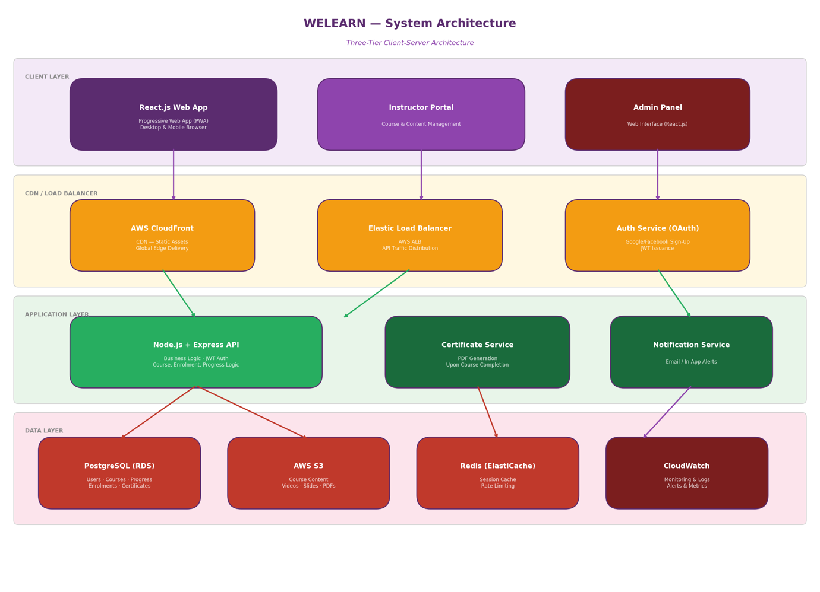

Technology Stack
Layer | Technology | Purpose
Web Frontend | React.js + Vite | Progressive Web App (PWA), responsive design
Backend API | Node.js + Express | REST API, business logic
Authentication | JWT + OAuth 2.0 (Google/Facebook) | Secure login + social sign-up
Primary Database | PostgreSQL (AWS RDS) | Users, courses, enrolments, progress
Content Storage | AWS S3 | Course videos, slides, images, PDFs
Caching | Redis (ElastiCache) | Session cache, rate limiting
CDN | AWS CloudFront | Global content delivery
CI/CD | GitHub Actions | Automated testing & deployment
Monitoring | AWS CloudWatch | Server health & error tracking

Component Interaction
- Sign-Up Flow: A new learner registers either via email/password or via one-click social sign-up (Google/Facebook OAuth). The API creates a user record in PostgreSQL and issues a JWT token.
- Course Browsing: The learner browses categories (Programming, Design, Arts and Crafts, etc.). The client requests GET /api/categories and GET /api/courses, which the API resolves from PostgreSQL, returning course metadata and S3-hosted thumbnail images.
- Course Enrolment & Content Access: Upon enrolling, the learner accesses lesson content. The API verifies enrolment, then returns a pre-signed S3 URL for the relevant video, slide deck, or reading material.
- Progress Tracking: As learners complete lessons and module quizzes, the client sends progress updates to the API, which persists them to PostgreSQL and recalculates overall course completion percentage.
- Certificate Generation: Upon 100% course completion, the API triggers a certificate-generation service that produces a downloadable PDF certificate, stored in S3 and linked to the learner's profile.

UML Diagrams

This section presents the core UML diagrams for WELEARN. All diagrams are described in structured textual form below and are produced as separate diagram artefacts in the GitHub repository.

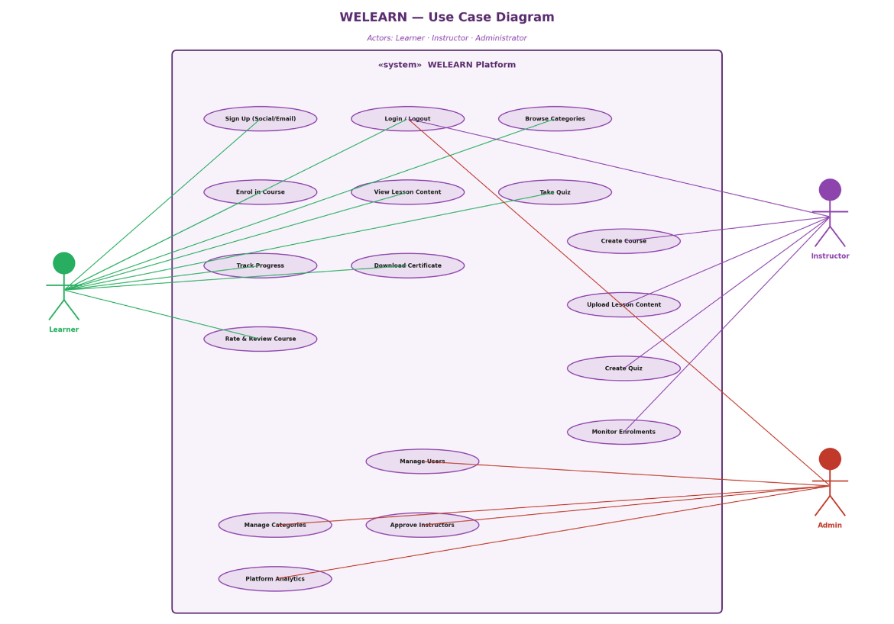
Use Case Diagram
WELEARN has three primary actors: Learner, Instructor, and Administrator.

Learner Actor Use Cases:
- Sign up (email or social login)
- Log in / Log out
- Browse course categories and subtopics
- Enrol in a course
- View lesson content (video, slides, readings)
- Take module quizzes
- Track personal progress
- Download completion certificate
- Leave course ratings and reviews

Instructor Actor Use Cases:
- Log in / Log out
- Create and manage courses and subtopics
- Upload lesson content (video, slides, documents)
- Create module quizzes
- Monitor learner enrolment and completion rates
- Respond to learner questions/reviews

Administrator Actor Use Cases:
- Manage all user accounts (learners and instructors)
- Approve new instructor applications
- Manage course categories and platform taxonomy
- View platform-wide analytics (enrolments, completions, popular categories)
- Moderate course content and reviews

Class Diagram — Core Entities
Class | Key Attributes | Key Methods
User | userId, name, email, passwordHash, authProvider, role, createdAt | login(), logout(), updateProfile()
Learner (extends User) | enrolledCourses[], progressRecords[], certificates[] | enrol(), trackProgress(), downloadCertificate()
Instructor (extends User) | expertiseArea, createdCourses[] | createCourse(), uploadContent(), viewEnrolments()
Category | categoryId, name, description, subtopics[] | addSubtopic(), removeSubtopic()
Course | courseId, title, categoryId, instructorId, lessons[], level | addLesson(), publish(), archive()
Lesson | lessonId, title, contentURL, type, duration | view(), markComplete()
Quiz | quizId, lessonId, questions[], passMark | submit(), score()
Enrolment | enrolmentId, learnerId, courseId, enrolledAt, status | activate(), deactivate()
Progress | progressId, learnerId, courseId, pctComplete, lastAccessed | update(), calculateCompletion()
Certificate | certId, learnerId, courseId, issuedAt, fileURL | generate(), download()
Relationships: Learner and Instructor both inherit from User (generalisation). Category contains many Courses (composition). Course contains many Lessons (composition). Lesson has one Quiz (association). Learner has many Enrolments (association). Learner has many Progress records (association). Learner earns many Certificates upon course completion (association).
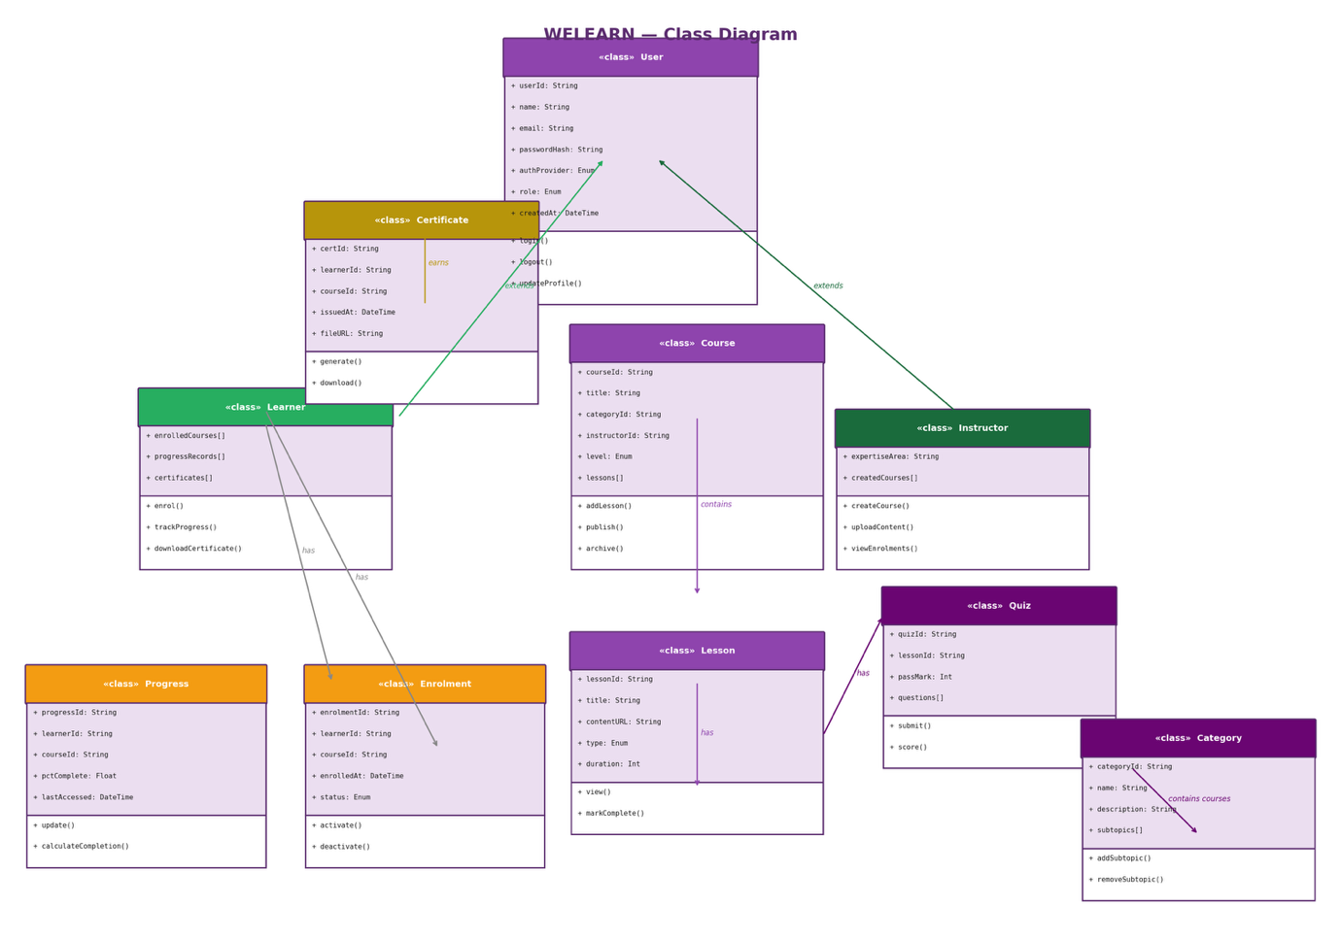

5.3 Sequence Diagram — Learner Sign-Up & Course Enrolment
- Learner opens WELEARN and taps "Sign up with Google" on the registration screen.
- Client redirects to Google OAuth consent screen; learner authorises access.
- Google returns an auth token to the WELEARN client.
- Client sends POST /api/auth/social-signup with the Google token to the Node.js API.
- Node.js API verifies the token with Google, then queries PostgreSQL: SELECT * FROM users WHERE email = ?.
- If no existing user, API creates a new user record in PostgreSQL with role = 'learner'.
- API generates a JWT token and returns it with the learner's profile.
- Client stores the JWT and redirects to the Course Catalogue screen.
- Learner browses categories and selects "Programming → JavaScript."
- Client sends POST /api/enrolments with courseId and JWT in the Authorization header.
- API creates an Enrolment record in PostgreSQL and returns confirmation.
- Learner is redirected to the course's first lesson; API returns lesson metadata and a pre-signed S3 URL for the content.

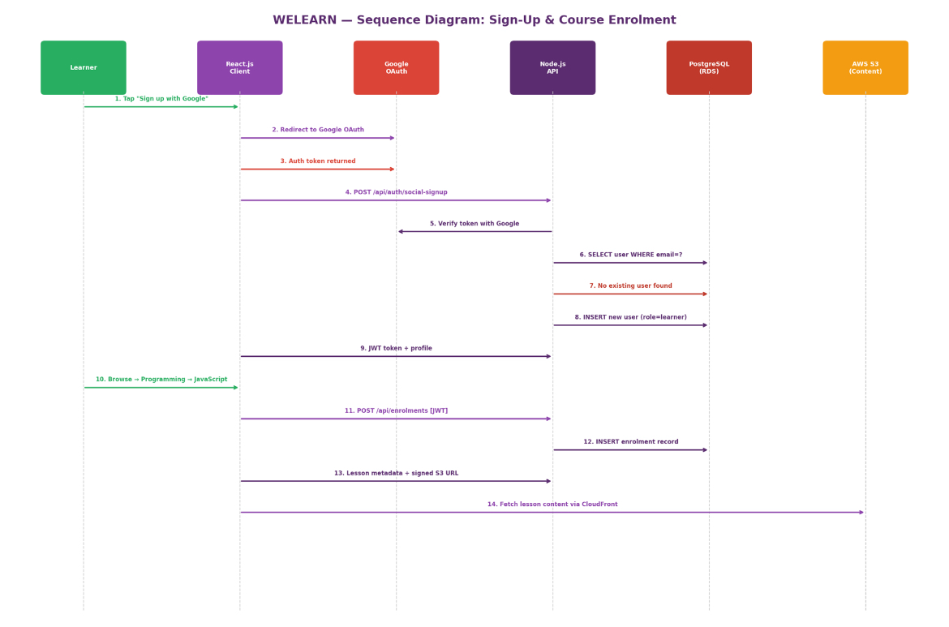

5.4 Activity Diagram — Course Completion & Certificate Flow
- Learner completes the final lesson in a course.
- System checks: Have all module quizzes been passed? If No → prompt learner to retake outstanding quizzes. If Yes → continue.
- System calculates overall course completion percentage from the Progress table.
- If completion = 100%: System triggers the Certificate Generation Service.
- Certificate Service renders a PDF certificate with learner name, course title, and completion date.
- Generated certificate is uploaded to AWS S3 and a Certificate record is created in PostgreSQL.
- Learner receives a notification: "Certificate ready for download."
- Learner downloads the certificate or shares it directly via a public verification link.

6. Project Plan

Work Breakdown Structure (WBS)
- Phase 1 – Planning: Define scope, assemble team, stakeholder meetings, risk assessment, project charter.
- Phase 2 – Requirements: Learner surveys, user stories, backlog creation, requirements document.
- Phase 3 – Design: UI/UX wireframes, system architecture, database design, UML diagrams, Figma prototype.
- Phase 4 – Implementation Sprint 1–2: Auth & social sign-up, course catalogue, category browsing.
- Phase 4 – Implementation Sprint 3–4: Lesson content player, quizzes, progress tracking, certificates.
- Phase 4 – Implementation Sprint 5–7: Instructor tools, admin panel, notifications, polish.
- Phase 5 – Testing: Unit tests, integration tests, UAT with sample learners, performance testing.
- Phase 6 – Deployment: CI/CD setup, production deployment, soft launch, public go-live.
- Phase 7 – Maintenance: Bug fixes, new course categories, analytics review, iterative improvements.

Gantt Chart
The Gantt chart below shows the timeline for all project phases across a 20-week delivery period:
Phase / Task | W1 | W2 | W3 | W4 | W5 | W6 | W7 | W8 | W9 | W10 | W11 | W12 | W13 | W14 | W15 | W16 | W17 | W18 | W19
1. Planning | █ | █
2. Requirements |  | █ | █
3. System Design |  |  | █ | █ | █
4a. Sprint 1–2 (Auth & Catalogue) |  |  |  |  | █ | █ | █ | █
4b. Sprint 3–4 (Lessons & Quiz) |  |  |  |  |  |  |  |  | █ | █ | █ | █
4c. Sprint 5–7 (Instructor & Admin) |  |  |  |  |  |  |  |  |  |  |  |  | █ | █ | █ | █ | █ | █
5. Testing (Ongoing) |  |  |  |  |  |  |  |  |  |  |  | █ | █ | █ | █ | █ | █ | █ | █
6. Deployment |  |  |  |  |  |  |  |  |  |  |  |  |  |  |  |  |  |  | █

Network Diagram (Critical Path Analysis)
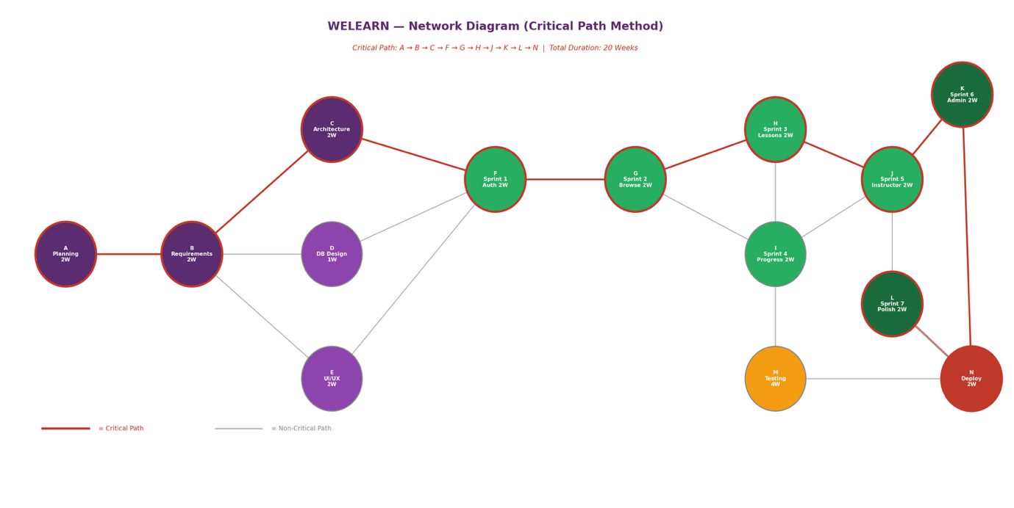
ID | Activity | Duration | Depends On | ES–EF | Notes
A | Project Planning | 2 weeks | — | 0–2 | Start node
B | Requirements Analysis | 2 weeks | A | 2–4
C | System Architecture Design | 2 weeks | B | 4–6 | Critical Path
D | Database Design | 1 week | B | 4–5 | Parallel with C
E | UI/UX & Figma Prototype | 2 weeks | B | 4–6 | Parallel with C
F | Sprint 1: Auth & Catalogue | 2 weeks | C, D | 6–8 | Critical Path
G | Sprint 2: Course Browsing | 2 weeks | F | 8–10 | Critical Path
H | Sprint 3: Lessons & Quiz | 2 weeks | G | 10–12 | Critical Path
I | Sprint 4: Progress & Certificates | 2 weeks | G | 10–12 | Parallel with H
J | Sprint 5: Instructor Tools | 2 weeks | H, I | 12–14 | Critical Path
K | Sprint 6: Admin Panel | 2 weeks | J | 14–16 | Critical Path
L | Sprint 7: Polish & Integration | 2 weeks | K | 16–18 | Critical Path
M | Testing & UAT | 4 weeks | H (start) | 12–18 | Overlaps sprints
N | Deployment | 2 weeks | L, M | 18–20 | Critical Path — End
Critical Path: A → B → C → F → G → H → J → K → L → N (Total: 20 weeks). Activities on the critical path have zero float and cannot be delayed without delaying the project.

7. Prototype Design (UI/UX)

Design Principles
- Clarity: Clean course catalogue with clear category and subtopic hierarchy, since WELEARN spans nine distinct skill domains.
- Low-Friction Onboarding: Social sign-up (Google/Facebook) reduces registration time to seconds.
- Mobile-Responsive: Fully usable on both desktop and mobile browsers given mixed-device access patterns.
- Progress Visibility: Clear visual indicators of course and module completion to motivate learners.
- Credibility: Clean certificate design and instructor profiles to build trust in course quality.

Figma Prototype — Key Screens
The following 10 key screens have been designed in Figma and are available in the GitHub repository under /prototype/figma-exports/:
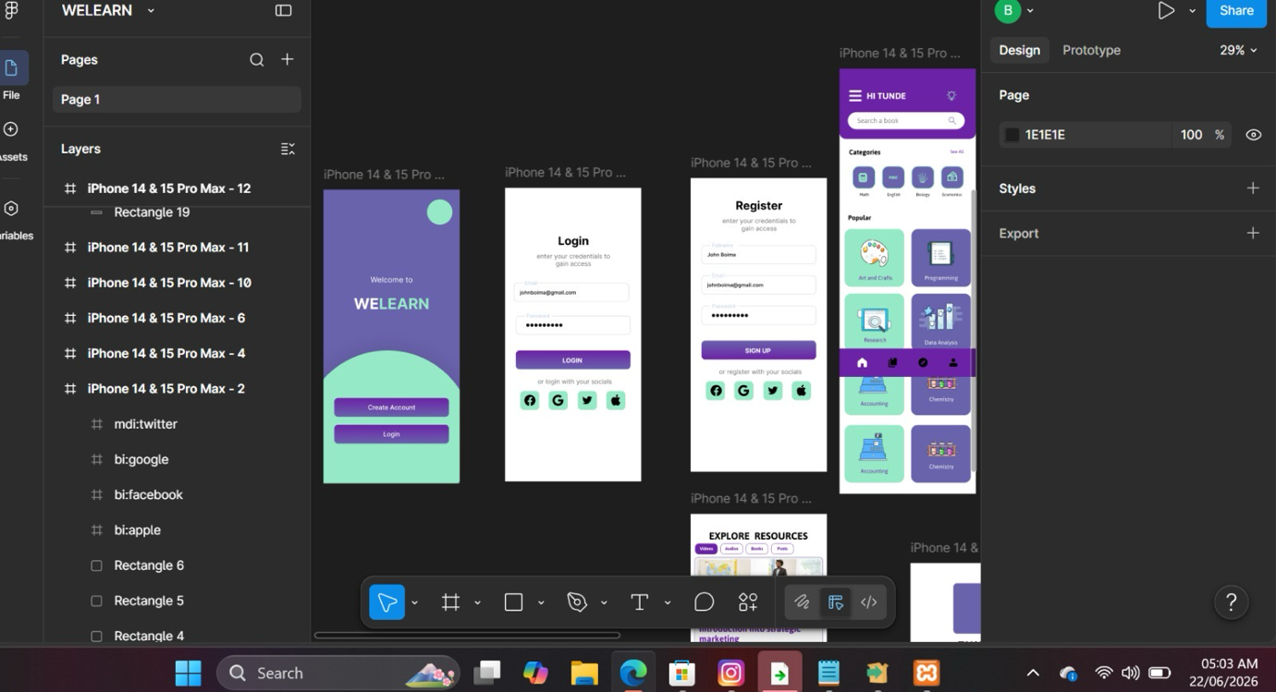
# | Screen Name | Description & Key UI Elements
1 | Sign Up Screen | Logo, tagline, 'Sign up with Google/Facebook' buttons, email fallback form.
2 | Login Screen | Email/password fields, social login shortcuts, 'Forgot Password' link.
3 | Home / Category Hub | Grid of 9 category cards (Programming, Design, Arts & Crafts, Accounting, Economics, Marketing, Database, Digital Imaging, Data Analysis) each with icon and course count.
4 | Category Detail Screen | Subtopic list for a selected category (e.g. Programming → HTML & CSS, JavaScript, Programming Logic) with course cards under each.
5 | Course Detail Screen | Course thumbnail, instructor info, syllabus/lesson list, rating, 'Enrol Now' button.
6 | Lesson Viewer | Video/slide content area, lesson list sidebar, progress bar, 'Mark Complete' button.
7 | Quiz Screen | Module quiz with multiple-choice questions, progress tracker, submit button.
8 | Learner Dashboard | Enrolled courses with progress rings, certificates earned, recommended next courses.
9 | Instructor Dashboard | Course management table, enrolment stats, 'Create New Course' action, learner Q&A.
10 | Admin Panel | User management, instructor approval queue, category management, platform analytics.

7.3 Design System
Element | Specification | Rationale
Primary Colour | #5B2C6F (Deep Purple) | Professional, skills/creative identity
Accent Colour | #8E44AD (Mid Purple) | Interactive elements, links, CTAs
Success Colour | #27AE60 (Green) | Completion states, certificates earned
Typography | Inter (headings & body) | Clean, modern, highly legible at small sizes
Base Font Size | 16px body, 24px headings | Readability across devices
Border Radius | 12px cards, 24px buttons | Modern, approachable feel
Grid System | 4-column mobile, 12-column desktop | Responsive layout consistency

8. GitHub Repository

8.1 Repository Structure
The WELEARN project is hosted on GitHub at: https://github.com/[your-username]/welearn-digital-public-good
- / (root) — README.md, LICENSE, .gitignore, package.json
- /docs — Project report, UML diagrams, architecture diagrams
- /prototype — Figma export files (10 screens)
- /client — React.js web app source code
- /server — Node.js + Express backend API source code
- /database — SQL schema files, migration scripts, seed data
- /tests — Unit tests (Jest), integration tests (Supertest)
- /.github/workflows — GitHub Actions CI/CD pipeline configurations

8.2 Collaboration Workflow
- The main branch always contains stable, production-ready code.
- Each feature is developed on a dedicated branch named feature/[feature-name].
- Pull Requests (PRs) require at least 1 reviewer approval before merging.
- GitHub Actions automatically runs all unit and integration tests on every PR.
- Commits follow Conventional Commits format (e.g., feat: add certificate generation).
- GitHub Issues track bugs and feature requests with labels: bug, enhancement, documentation.

9. License & Open Source Compliance

9.1 Selected License: MIT License
- MIT is a permissive open source license allowing anyone to use, copy, modify, and distribute WELEARN — maximising its accessibility as a Digital Public Good.
- It is compatible with the Digital Public Goods Standard (DPGS).
- It is simple and widely understood, reducing friction for NGOs, training centres, or governments wishing to adapt WELEARN for other contexts.
- It places minimal restrictions on redistribution, enabling WELEARN to reach the widest possible learner population.

9.2 Third-Party Attributions
Library / Resource | Version | License | Usage in WELEARN
React | 18.x | MIT | Web frontend framework
Node.js / Express | 20.x / 4.x | MIT | Backend API server
PostgreSQL | 15.x | PostgreSQL License | Primary database
JSON Web Tokens | 9.x | MIT | Authentication tokens
Passport.js (OAuth) | 0.7.x | MIT | Social sign-up integration
Inter Font | 3.x | SIL OFL 1.1 | UI typography

10. Conclusion

WELEARN represents a focused, practical response to one of Sierra Leone's most pressing challenges: a generation of educated but underemployed youth. By directly addressing the gap between formal education and employable, market-relevant skills, WELEARN advances United Nations Sustainable Development Goal 4 — ensuring inclusive and equitable quality education and lifelong learning for all — with a specific emphasis on real-world economic outcomes.
The design of WELEARN applies rigorous software engineering principles throughout: an Agile SDLC ensures responsive, learner-centred development; a three-tier cloud architecture provides scalability; comprehensive UML modelling defines clear system behaviour; and a 20-week project plan with Gantt chart and critical path analysis ensures disciplined delivery.
The MIT open source license ensures WELEARN can be freely adopted and scaled by training organisations and governments across the region. The Figma prototype demonstrates a clean, low-friction user experience — from one-click social sign-up to a clear, skills-organised course catalogue — designed for learners who need practical results, not just credentials.
WELEARN is ultimately a bridge — between classroom and career, between ambition and opportunity — giving every learner the tools to convert education into employability.

11. References

United Nations. (2015). Transforming our world: The 2030 Agenda for Sustainable Development. United Nations General Assembly.
UNESCO. (2023). Global Education Monitoring Report 2023: Technology in Education. Paris: UNESCO.
International Labour Organization. (2023). Global Employment Trends for Youth 2023. Geneva: ILO.
Ministry of Basic and Senior Secondary Education, Sierra Leone. (2022). Education Sector Plan 2022–2026. Freetown: MBSSE.
Digital Public Goods Alliance. (2023). Digital Public Goods Standard v1.1.4. Retrieved from https://digitalpublicgoods.net/standard/
Sommerville, I. (2016). Software Engineering (10th ed.). Pearson Education.
Pressman, R. S., & Maxim, B. R. (2019). Software Engineering: A Practitioner's Approach (9th ed.). McGraw-Hill.
React Documentation. (2024). Getting Started. Retrieved from https://react.dev/
Node.js Foundation. (2024). Node.js v20 Documentation. Retrieved from https://nodejs.org/en/docs/
PostgreSQL Global Development Group. (2024). PostgreSQL 15 Documentation. Retrieved from https://www.postgresql.org/docs/15/

